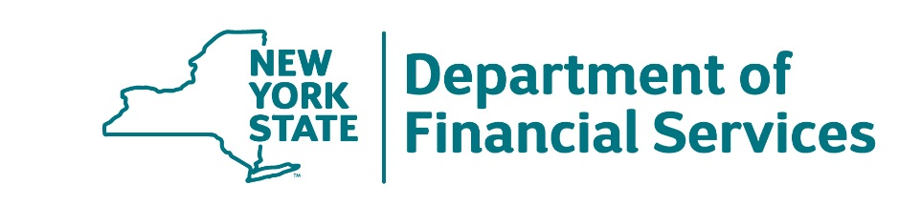

**Presents…**

**FINANCING YOUR EDUCATION…**

**DATE & TIME: October 19th, 2023 @ 6:00pm**

**LOCATION: Room 42 (Enter though Gator Lobby)**

**This one-hour workshop includes a presentation, Q&A session and helpful brochures and takeaways on the following subjects:**

* **Filling out the FAFSA**
* **Grants**
* **Scholarships**
* **Types of loans**
* **Determining the amount of aid you qualify for**
* **Helpful New York State programs**

If you need immediate help with any financial question, call the DFS Consumer Hotline at **(800) 342-3736** (8:30 a.m. to 4:30 p.m., Monday through Friday). You can also find more information or file a complaint online at **www.dfs.ny.gov.**

*****

Llámenos al 800-342-3736 si necesita ayuda gratis en su idioma

請給我們打電話號碼 : 800-342-3736, 要求免費的語言協助服務。

Чтобы получить бесплатные переводческие услуги, позвоните, пожалуйста, по следующему номеру: 800-342-3736

Chiamare il 800-342-3736 per assistenza linguistica gratuita

Tanpri rele nou nan 800-342-3736 pou jwenn sèvis èd gratis nan lang

전화800-342-3736 로 무료 언어 지원 서비스를 요청하십시오

Pod numerem telefonu 800-342-3736 otrzymają Państwo bezpłatną pomoc językową